- Candidate-Elimination Algorithm

Aim:
To implement and demonstrate the Candidate-Elimination algorithm for finding the version space, i.e., the set of all hypotheses that are consistent with the given training examples.

Algorithm:
• Define the training dataset with attributes and target class.
• Initialize the Specific Hypothesis (S) with the first positive training example.
• Initialize the General Hypothesis (G) with the most general hypothesis (? for every attribute).
• For each training example:
- If the example is positive (Yes):
  - Update the Specific Hypothesis by generalizing inconsistent attributes.
  - Remove inconsistent hypotheses from the General Hypothesis.
- If the example is negative (No):
  - Specialize the General Hypothesis to exclude the negative example while remaining consistent with the Specific Hypothesis.
• Remove duplicate and overly general hypotheses.
• Display the final Specific Hypothesis and General Hypothesis.

Program:
import pandas as pd
import numpy as np

data = [
['Sunny', 'Warm', 'Normal', 'Strong', 'Warm', 'Same', 'Yes'],
['Sunny', 'Warm', 'High', 'Strong', 'Warm', 'Same', 'Yes'],
['Rainy', 'Cold', 'High', 'Strong', 'Warm', 'Change', 'No'],
['Sunny', 'Warm', 'High', 'Strong', 'Cool', 'Change', 'Yes']
]

columns = ['Sky', 'AirTemp', 'Humidity', 'Wind', 'Water', 'Forecast', 'EnjoySport']

df = pd.DataFrame(data, columns=columns)

print("Training Dataset:\n")
print(df)

concepts = np.array(df.iloc[:, :-1])
target = np.array(df.iloc[:, -1])

specific_h = concepts[0].copy()

general_h = [["?" for _ in range(len(specific_h))] for _ in range(len(specific_h))]

for i, h in enumerate(concepts):
if target[i] == "Yes":
for x in range(len(specific_h)):
if h[x] != specific_h[x]:
specific_h[x] = "?"
general_h[x][x] = "?"
else:
for x in range(len(specific_h)):
if h[x] != specific_h[x]:
general_h[x][x] = specific_h[x]
else:
general_h[x][x] = "?"

general_h = [g for g in general_h if g != ["?"] * len(specific_h)]

print("\nSpecific Hypothesis (S):")
print(specific_h)

print("\nGeneral Hypothesis (G):")
for g in general_h:
print(g)
Output:
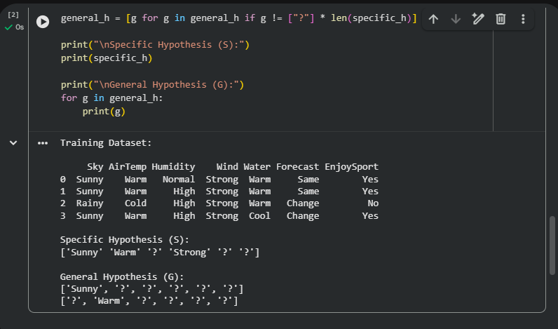
Result:
The Candidate-Elimination algorithm was successfully implemented. Using the given training data, the algorithm computed the Specific Hypothesis (S) and the General Hypothesis (G), representing the version space of all hypotheses that are consistent with the training examples.

